**Monster Attack Core Loop Mechanism Documentation**

By Tegar Cahya Bayu Siregar

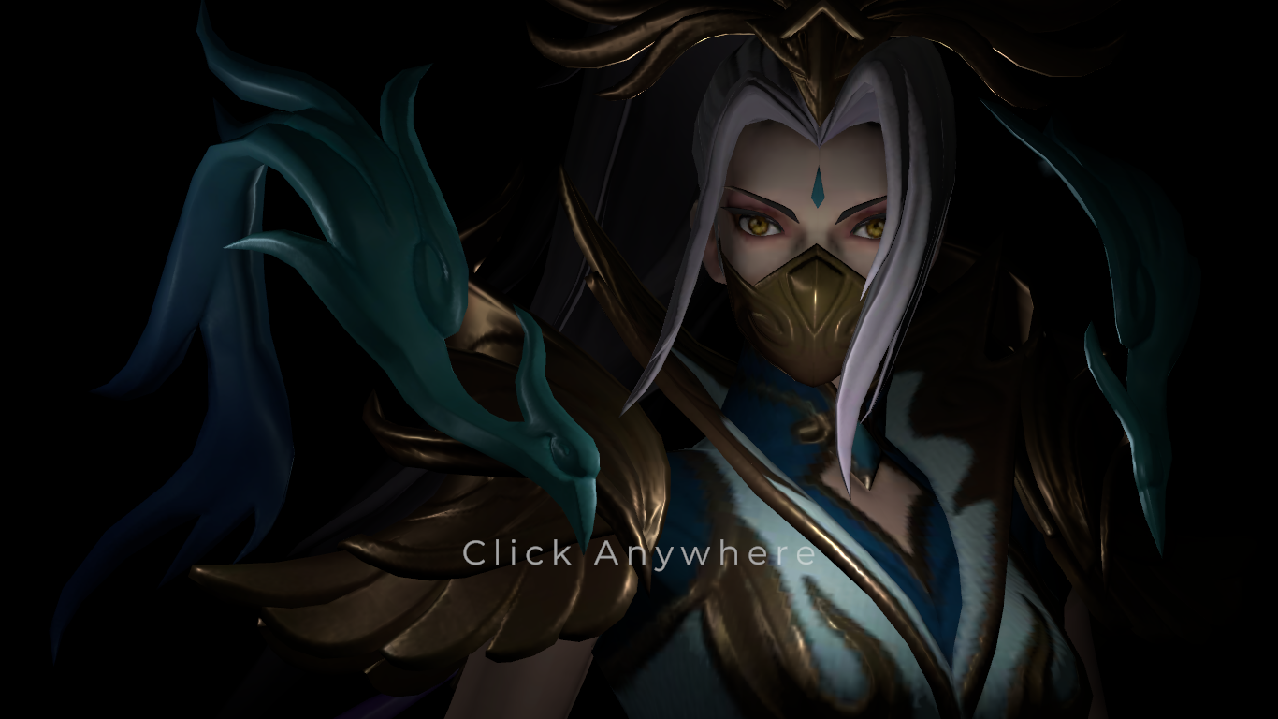

1. Architecture Overview

The Turn-Based Combat System is built with flexibility and modularity in mind, enabling easy customization for future features and adaptations

* My Key Components
  + - **Character Class Base** : Represents each character template in the game, storing relevant stats ( Attack, Health, Defend) and their Buff-Debuff affected stats.
    - **Character Class** Contracted with **Interface** called **ICharacterBehaviour**. That approach ensures each character have the same behaviour.
    - **Character Ability** also contracted with **Interface** called **IBuffAbility** and **IDebuffAbility**. Those interface also contracted with more general interface called **IAbility**.
    - **BattleFlow** managed by **BattleManger** and **Drafter**. **Battle Manager** will handle the **game battle state flow** and **Drafter** will handle **character state flow**
    - **CharacterBaseInformation** is stored in **ScriptableObject**. Ensuring the easiest game balancing approach.
* **Game Battle State Flow**

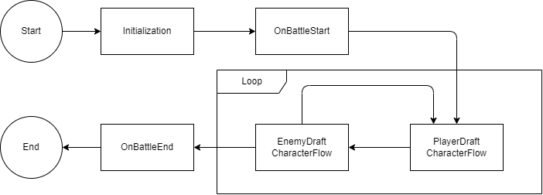

* **Character State Flow**

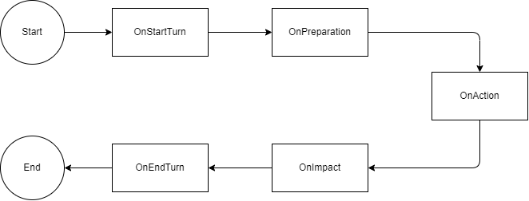

1. Character Overview

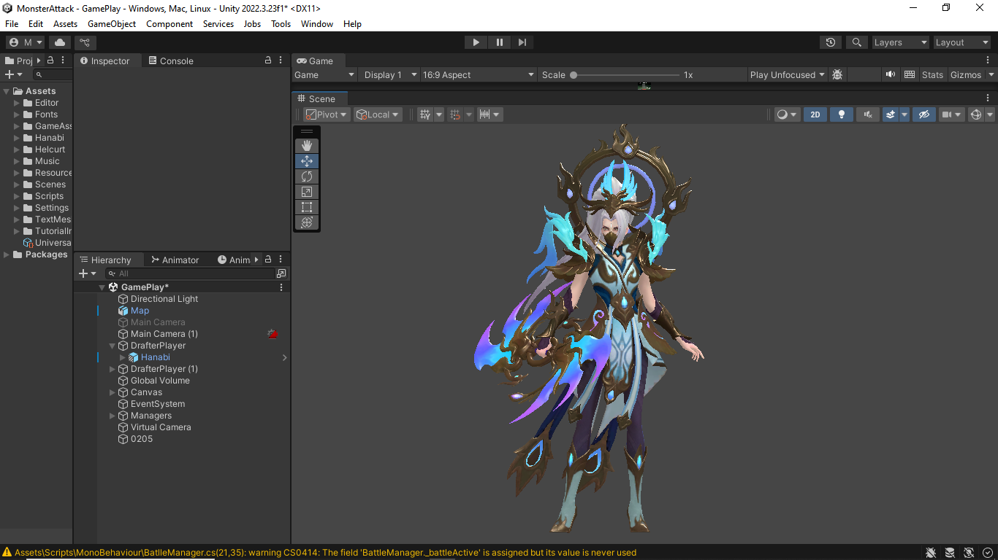

* Attack Ability : Attacking enemy with 100% of her modified attack stats
* Defend Ability : Increasing her defend and her allies with 100% of her modified defend stats
* Passive Ability : Attacking nerby Enemy with 40% of damage amount in her Attack Ability

In order to achieve those behaviour where each character has their own signature move, use of Character flow is really Important. Here is example of Hanabi Character Flow.

* OnStartTurn : Check any her buff available within her team mates. If exist, then decrease the duration of the buff by 1. Lasting for 2 turn.
* OnPreparation: binding her skills button
* OnAction : Selected skills by players will executed. Performing animation based on CharacterAbilitiesEnum. Because of Character is contracted by ICharacterBehaviour. Each character must have function PerformAction that will trigger their own signature move.
* OnImpact: Check if any allies is giving her buff or enemy giving her debuff
* OnEndTurn: Check if any allies or enemy giving her buff or debuff

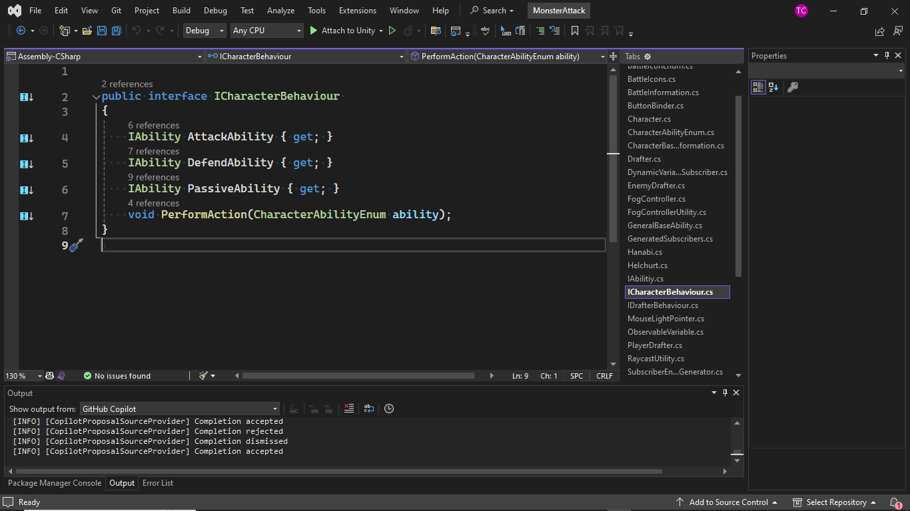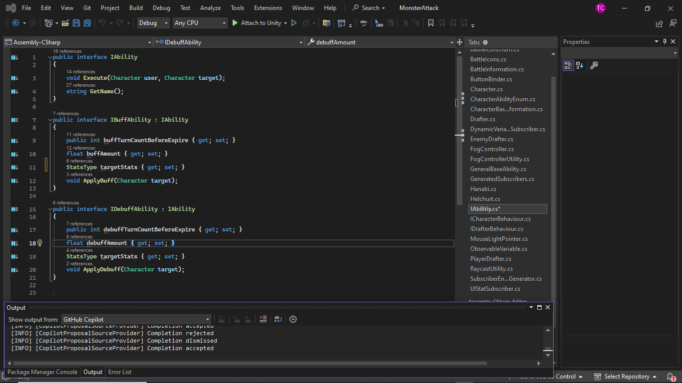

**Example Implementation**

* **Helcurt Attack Ability**

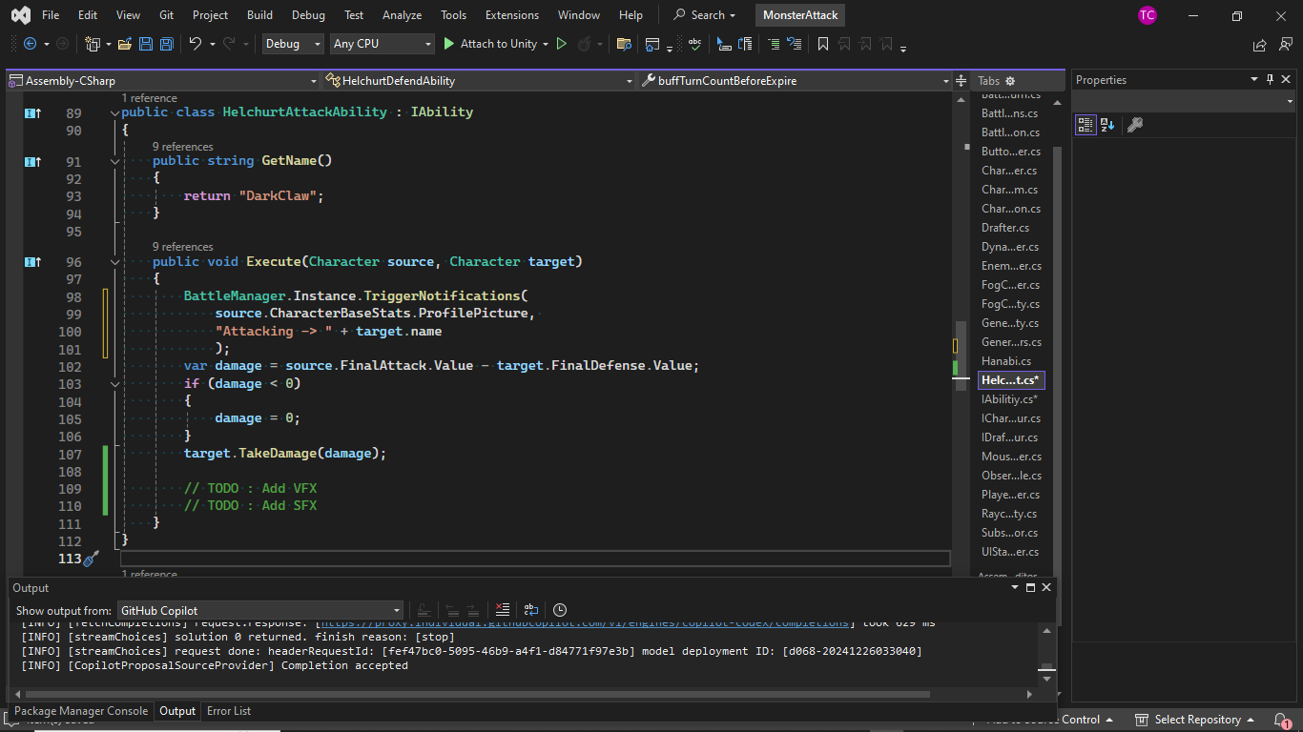

* **Helcurt Passive Abiltiy (Giving Debuff)**

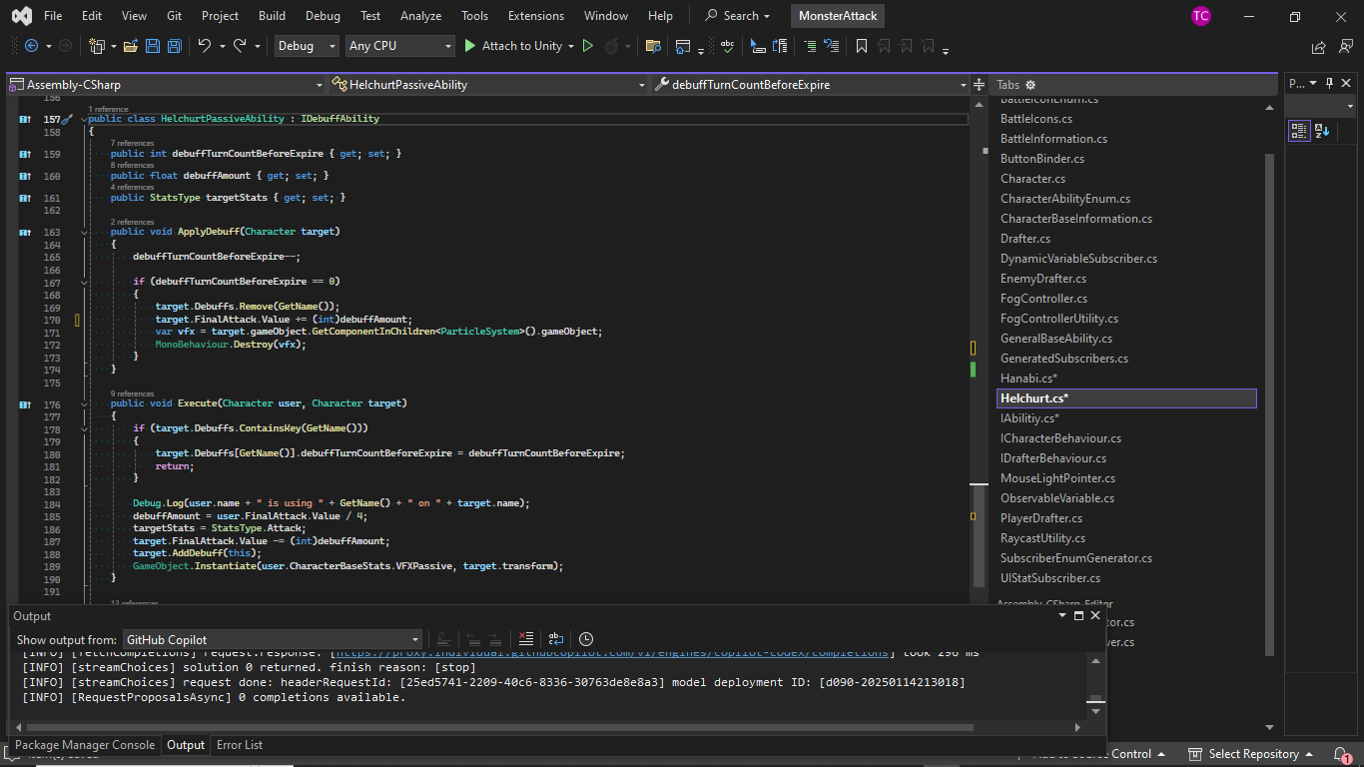

* **Specialized Perform Action that support different signature skills and behaviour**
  + **Helcurt**

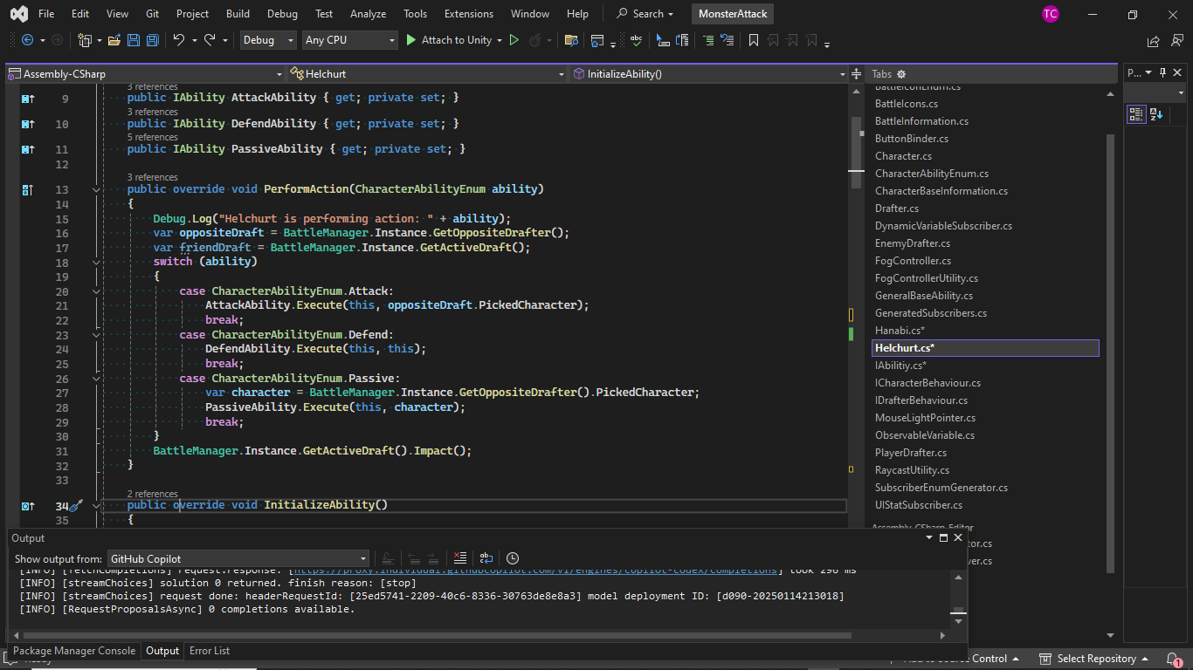

* + **Hanabi**

